Aim: Case Study on Raspberry Pi

1. Introduction to Raspberry Pi Architecture
The Raspberry Pi is a low-cost, credit-card sized single-board computer developed to promote computing education and rapid prototyping. Over time, it has evolved into a powerful platform used in industrial automation, IoT systems, and laboratory environments.
Unlike traditional microcontrollers, the Raspberry Pi runs a full Linux operating system. This allows developers to use high-level programming languages such as Python, Java, and C++, and to manage multiple processes simultaneously. The architecture of the Raspberry Pi is based on a System on Chip (SoC) designed by Broadcom. The SoC integrates the CPU, GPU, RAM, and peripheral interfaces into a compact form factor.
A key feature of the Raspberry Pi is its General Purpose Input Output (GPIO) header, which allows direct interaction with sensors, actuators, and external devices. This architecture makes the Raspberry Pi suitable for data-intensive applications, real-time monitoring, and intelligent decision-making systems.


2. Hardware Specifications and GPIO Functionality
The Raspberry Pi 4 and 5 models include powerful quad-core processors that significantly improve performance compared to earlier versions. They support high-speed connectivity options such as Gigabit Ethernet, dual-band Wi-Fi, and Bluetooth, making them ideal for network-based applications.
The GPIO header consists of 40 pins that provide power, ground, and communication interfaces. These pins support multiple protocols used in sensor communication. I2C is commonly used for connecting multiple low-speed sensors using only two wires. SPI is used for high-speed communication with devices such as ADCs and displays. UART is used for serial communication, especially in debugging and communication with GPS or other modules.
The flexibility of GPIO allows engineers to design customized hardware interfaces for various sensing applications.

3. Sensor Integration and Signal Processing
In laboratory environments, sensors play a crucial role in collecting real-time data from physical systems.
Digital sensors provide output in binary form and can be directly interfaced using communication protocols such as I2C or SPI. Examples of digital sensors include temperature, humidity, and motion sensors. Analog sensors, on the other hand, produce continuous voltage signals that represent physical quantities such as light intensity or gas concentration.
Since the Raspberry Pi does not have a built-in ADC, external converters such as MCP3008 are used to convert analog signals into digital values. Signal processing techniques are applied to filter noise, normalize data, and extract meaningful insights from raw sensor readings.

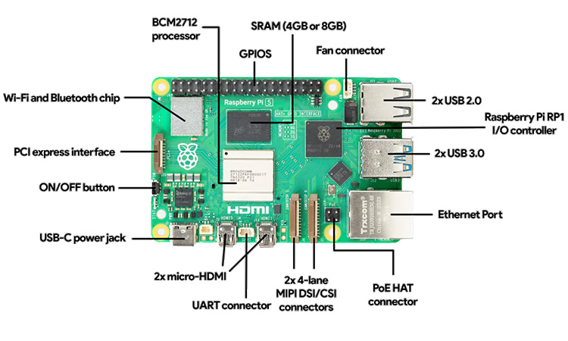

4. Case Study: Environmental Monitoring System
A smart environmental monitoring system can be developed using Raspberry Pi to measure temperature, humidity, light intensity, and soil moisture. Sensors such as BME280 and TSL2561 can be connected using I2C, while analog sensors can be interfaced using an ADC like MCP3008.
The system can continuously collect data and store it locally using databases such as SQLite or InfluxDB. This approach, known as edge computing, ensures that data is processed locally without relying entirely on cloud services.
The Raspberry Pi camera module can also be used to capture images for visual monitoring and analysis. This system can be applied in laboratories, greenhouses, and industrial environments for real-time monitoring.

5. Networking and Remote Management
The Raspberry Pi supports headless operation, meaning it can run without a monitor or keyboard. Secure Shell (SSH) allows users to remotely access and control the device from another computer. MQTT is a lightweight communication protocol widely used in IoT applications for transmitting sensor data. The Raspberry Pi can act as an MQTT broker, collecting and distributing data from multiple devices.
Web frameworks such as Flask and Dash can be used to create dashboards for visualizing sensor data in real time. These capabilities make the Raspberry Pi suitable for remote monitoring and control systems.
6. Advanced Applications: Vision and AI
Modern Raspberry Pi systems support machine learning and computer vision applications. Using camera modules and libraries such as OpenCV, the system can detect objects and monitor changes in the environment.
TensorFlow Lite enables the deployment of lightweight AI models on the Raspberry Pi. Applications include anomaly detection, equipment monitoring, and automated quality control. Thermal imaging sensors can be integrated to detect overheating in electronic components.
These advanced capabilities expand the use of Raspberry Pi in intelligent systems.

7. Comparison with Alternative Platforms
Arduino is a microcontroller-based platform designed for simple and low-power applications.
It is suitable for tasks that require precise timing and minimal processing. In contrast, Raspberry Pi is a full-fledged computer capable of running complex software and handling large datasets. While Arduino is energy-efficient, Raspberry Pi offers greater flexibility and functionality.
The choice between the two depends on the application requirements. In many cases, both platforms can be used together in hybrid systems.
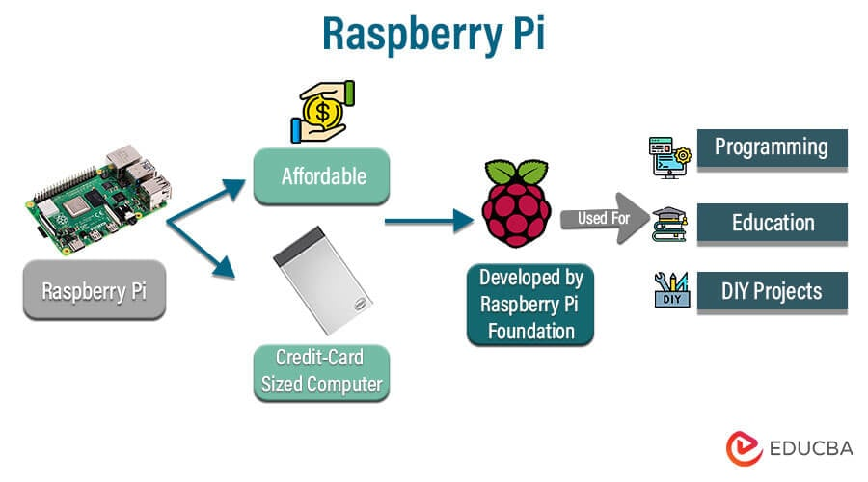

8. Conclusion
The Raspberry Pi has emerged as a powerful tool for sensor-based applications in laboratories and industries. Its ability to combine hardware interfacing with advanced software capabilities makes it highly versatile.
By supporting various communication protocols and external modules, it enables efficient data collection and processing. The integration of networking and AI further enhances its capabilities. As technology continues to evolve, the Raspberry Pi will play a key role in the development of smart and automated systems

